BSCS-3B

Muhammad Abdullah : 53457

Database Lab 5

Ms.Ayesha Majid

Author_ID

Title

Book_ID

BOOK

Author

Author_ID

Author_Name

**TASK 2**

**Creating Author Table:**

**Query:**

CREATE TABLE Authors (Auth_ID INT PRIMARY KEY,Auth_Name VARCHAR2(75));

DESC Authors;

**Output:**

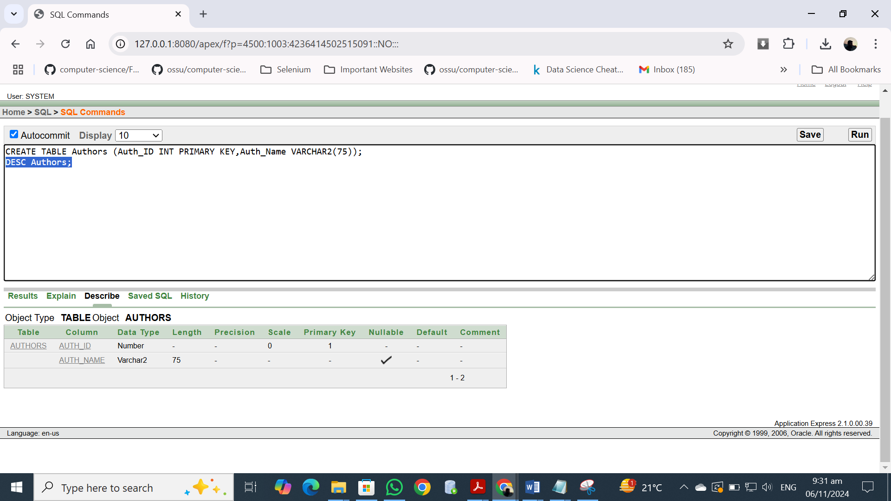

**Creating Books Table:**

**Query:**

CREATE TABLE Books(Book_ID INT PRIMARY KEY,Title VARCHAR2(100) NOT NULL, Auth_ID INT,FOREIGN KEY (Auth_ID) REFERENCES Authors(Auth_ID));

DESC Books;

**Output:**

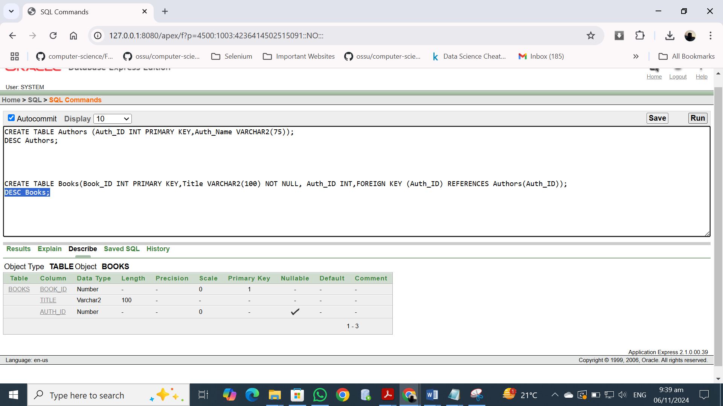

**Tables after inserted Values:**

**Authors:**

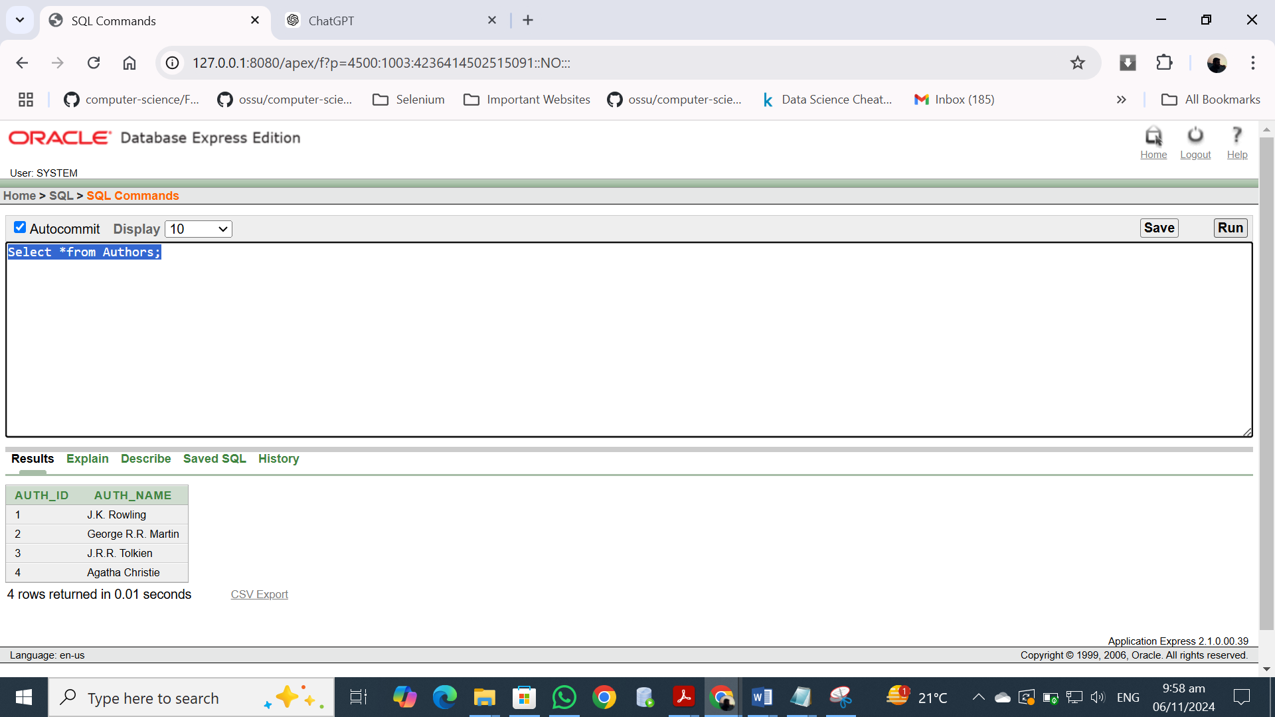

**Books:**

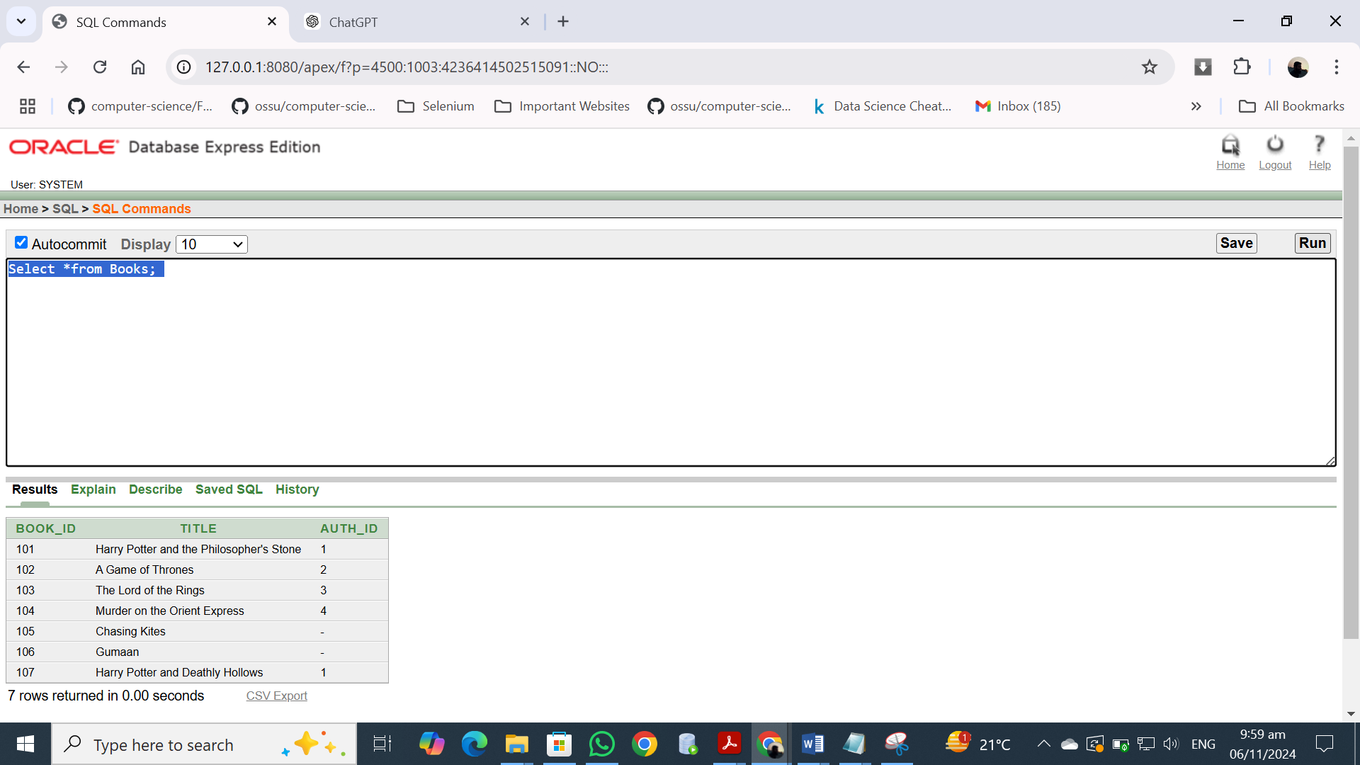

**TASK 3 : Joins**

**Question 1:**

**Query:**

SELECT Books.Book_ID, Books.Title,Authors.Auth_ID,Authors.Auth_Name

FROM Books

INNER JOIN Authors ON Books.Auth_ID = Authors.Auth_ID;

**Query:**

